***Software Requirement Specifications***

***[ECommerce-Website]***

***Version: [1.0.0]***

| *Course Code* | *SE2002* |
| --- | --- |
| *Instructor* | *Dr. Syed Muazzam Ali Shah* |
| *Project Team* | 1. *Sameel Ashar (21K-4659)* 2. *Muhammad Arif (21K-3416)* 3. *Maaz Siddiqui (21K-3187)* |
| *Submission Date* | *03-Dec-2023* |

***Table of Contents***

|  | *1.1.* |  | *Purpose of Document..............................................................................................................................* |
| --- | --- | --- | --- |
|  | *1.2.* |  | *DocumentConventions.............................................................................................................................* |
|  | *1.3.* |  | *Intended Audience and Reading Suggestions* *....................................................................................................................................**..........* |
|  | *1.4.* |  | *Product Scope**.............................................................................................................................* |
| ***2.*** | ***OVERALL SYSTEM DESCRIPTION........................................................................................................................*** | | |
|  | *2.1.* |  | *Project Perspective.................................................................................................................................* |
|  | *2.2.* |  | *Product Functions**........................................................................................................................* |
|  | *2.3.* |  | *User Classes and Characteristicss............................................................................................................................* |
|  | *2.4.* |  | *Operating Environment**.................................................................................................................................* |
|  | *2.5.* |  | *Design and Implementation Constraints**............................................................................................................................................* |
|  | *2.6.* |  | *User Documentation**...........................................................................................................................* |
|  | *2.7*. |  | *Assumptions and Dependencies**.......................................................................................................................**...............* |
|  |  |  |  |
| ***3.*** | ***EXTERNAL INTERFACE REQUIREMENTS.............................................................................................................*** | | |
|  | *3.1.* |  | *User Interfaces........................................................................................................................................* |
|  | *3.2.* |  | *Hardware Interfaces...............................................................................................................................* |
|  | *3.3.* |  | *Software Interfaces..................................................................................................................................* |
|  | *3.4.* |  | *Communications Interfaces.....................................................................................................................* |
| ***4.*** | ***System Features............................................................................................................................*** | | |
| *4.1.* | | *System Feature 1..................................................................................................................................* | |
| *4.2.* | | *System Feature 2 so on**..................................................................................................................................................* | |
| ***5.*** | ***NON-FUNCTIONAL REQUIREMENTS............................................................................................................******........*** | | |
|  | *5.1.* |  | *Performance Requirements.......................................................................................................................* |
|  | *5.2.* |  | *Safety Requirements................................................................................................................................* |
|  | *5.3.* |  | *Security Requirements.............................................................................................................................* |
|  | *5.4.* |  | *Software Qualtiy Attributes...............................................................................................................................* |
|  | *5.5* |  | *Business rules* |
| ***6.*** | ***SYSTEM ARCHITECTURE............................................................................................................................******....................*** | | |

***SOFTWARE REQUIREMENT SPECIFICATIONS***

***(SRS)***

1. ***Introduction***
   1. ***Purpose of Document:***

*The purpose of this document is to outline the functionalities of our e-commerce platform. This platform aims to provide a seamless experience for sellers to list their products and buyers to browse, purchase, and complete transactions. The document will provide a comprehensive imitation of an e-commerce website, detailing the processes involved for both sellers and buyers. Essential explanations and models will be presented to enhance the understanding of the project, including features accessible to users.*

* 1. ***Document Conventions:***

*This document will be using Arial as its primary font. Main Heading will be of font size 22 with text being bold and Italic, All the sub-headings will be of font size 17 with text being bold and Italic and content or body of the heading will be of font size 15 with text being Italic.*

* 1. ***Intended Audience and Reading Suggestions:***

| ***Terms, Acronyms and Abbreviations*** | ***Description*** |
| --- | --- |
| *Host* | *Person who creates the website for online shopping.* |
| *Guest* | *Person who buys the products listed on the website.* |
| *Listing* | *Products which were added by Host and are to be sold.* |
| *API* | *Application Programming Interface* |

* 1. ***Project Scope:***

*The EShop Connect project aims to provide users in Pakistan with a comprehensive e-commerce website, facilitating seamless transactions for both sellers and buyers. The platform allows sellers to showcase their products, and buyers can easily browse, purchase, and enjoy a secure and user-friendly shopping experience.*

1. ***Overall System Description***
   1. ***Project Perspective:***

*Our e-commerce platform is designed as a two-sided marketplace, connecting sellers who offer various products with buyers interested in making purchases. This platform serves as a dynamic marketplace where buyers can explore a diverse range of products and sellers can showcase their offerings. As of now, there is a significant market gap in Pakistan where conventional methods of purchasing, such as visiting physical stores or using limited online options, are prevalent. To tap into this extensive market, we aim to build a robust e-commerce platform that revolutionizes the way people buy and sell products.*

* 1. ***Project Functions:***

*The primary objective of this e-commerce website project is to offer a platform that provides users with convenient and cost-effective shopping alternatives in comparison to traditional retail methods. Unlike physical stores, our e-commerce platform aims to deliver a diverse range of products directly to the customers' fingertips, providing a seamless and enjoyable shopping experience.*

* 1. ***User Classes and Characteristics:***
* *An e-commerce website typically involves diverse user classes, each with distinct characteristics and roles. Guests, as unregistered visitors, have limited access to features, primarily focused on browsing products, adding items to the cart, and initiating the checkout process. Registered users, or customers, enjoy full access, including the ability to save favorite items, manage the shopping cart, track order history, update personal information, and submit product reviews. Administrators, operating on the backend, hold administrative privileges, overseeing product listings, user accounts, order processing, and website content. Customer support users handle inquiries, provide assistance, and may process returns. Vendors or sellers manage their product listings, inventory, and order processing*
  1. ***Operating Environment:***

*This software will run in hp elite book which contains 16 GB of ram. This software will run on Windows 10 and onwards on VMware virtual machines containing Ubuntu 22.10 and visual studio code.*

* 1. ***Design and implementation System Constraints:***

*This project is currently deployed using a local host and is not up on a proper running server. Furthermore, the project is built as the project for Database Systems and Software Design and Analysis course so the scope of the project currently is small. The app is for Pakistanis so there will be a language barrier for users who don’t speak Urdu and English. Further constraints are mentioned in section 3.*

* 1. ***User Documentation:***

*Users of the e-commerce platform should have the capability to explore and retrieve product information based on their preferences. This includes searching for products available in a given category, with the ability to filter results by date and time. The platform will cater to three distinct user roles: Guest Customer, Host Customer, and Application Admin, each with specific privileges. Both Guests and Hosts must complete a login or registration process to access the platform. Once logged in, users can manage their profiles, including the option to add, view, edit, and delete their information. Language preferences can also be adjusted.*

*Guests can browse and view products within their desired category. They have the ability to search for products, explore specific, popular, and trending items, and view ratings. Communication with sellers is facilitated through a comments section for inquiries, and they can also review past comments from other customers. Guests can add products to their favorites, view them in a dedicated tab, or proceed with bookings, pending confirmation from the seller. Reservation cancellations may be subject to charges specified by the seller. Guests can view their transaction history, itinerary, and provide feedback on products and sellers. After completing a transaction, guests can rate the seller and the product.*

* *Guests can browse and view products within their desired category. They have the ability to search for products, explore specific, popular, and trending items, and view ratings. Communication with sellers is facilitated through a comments section for inquiries, and they can also review past comments from other customers. Guests can add products to their favorites, view them in a dedicated tab, or proceed with bookings, pending confirmation from the seller. Reservation cancellations may be subject to charges specified by the seller. Guests can view their transaction history, itinerary, and provide feedback on products and sellers. After completing a transaction, guests can rate the seller and the product.*
* ***Hosts can create and manage product listings, including details and restrictions. They have the freedom to edit or delete their listings and can respond to guest questions in the comments section. Hosts may opt to pay for promotional features to enhance the visibility of their listings. The reservations tab allows hosts to review and manage reservation requests, view guest ratings, and accept or reject reservations.***

***User Personas:***

***HOST***

*An example is Ayesha, a 36-year-old female living in a suburban home with her family. Facing financial challenges, Ayesha decides to generate additional income by listing her handmade crafts on the e-commerce platform. Over time, her products gain popularity, and she earns a steady income, achieving financial stability..*

***GUEST***

*Consider Bilal, a 28-year-old professional working in a corporate setting. Bilal frequently travels for business and relies on the e-commerce platform to find suitable and reliable products for his travels. The platform's convenience and reliability make it Bilal's go-to choice for all his business-related purchases.*

* 1. ***Assumptions and Dependencies:***

***Assumptions:***

*It is assumed that project was started in september mid of 2023 so that proper timely working and strategy can be shown with the use of UML diagrams, Architectures, Design Strategy Phases to ensure proper development and so that the project can be deployed till the December end as per the instructor’s(client) need.*

***Dependencies:***

*Not Applicable*

1. ***External Interface Requirements***
   1. ***User Interfaces:***

*This app will provide an easy and understandable graphical user interface.*

* 1. ***Hardware Interfaces:***

*This software is executed on hp aero 13 and is an android application-based software which is made to be used on android smartphones, the app uses touch screen of android smartphone to navigate, perform tasks which user wants to perform, to enter user or listing data and uses android notification manager for any notification and updates.*

* 1. ***Software Interfaces:***

*This software uses FASTAPI local host server for the MySQL database and uses html css to display the front of the app on google chrome web browser. This app uses python libraries like sqlalchemy, pedantic for database and its schemas and FASTAPI for using API to communicate between PostgreSQL database and our frontend application.*

* 1. ***Communication Interfaces:***

*This software uses google chrome to execute on it. It uses https protocols to communicate between API and database.*

1. ***SYSTEM FEATURES***

*This section outlines the various functionalities that constitute the core capabilities of our e-commerce website. These features collectively contribute to creating a robust and user-friendly platform for online shopping, ensuring a seamless experience for our customers.*

***Front Page Of Website:***

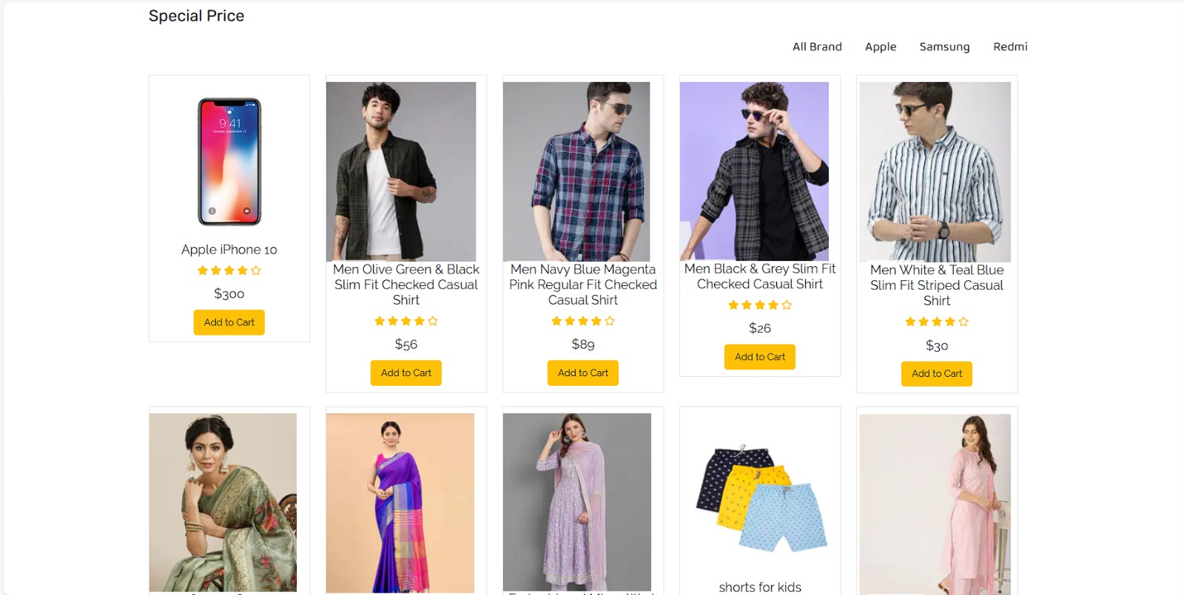

***View Product:***

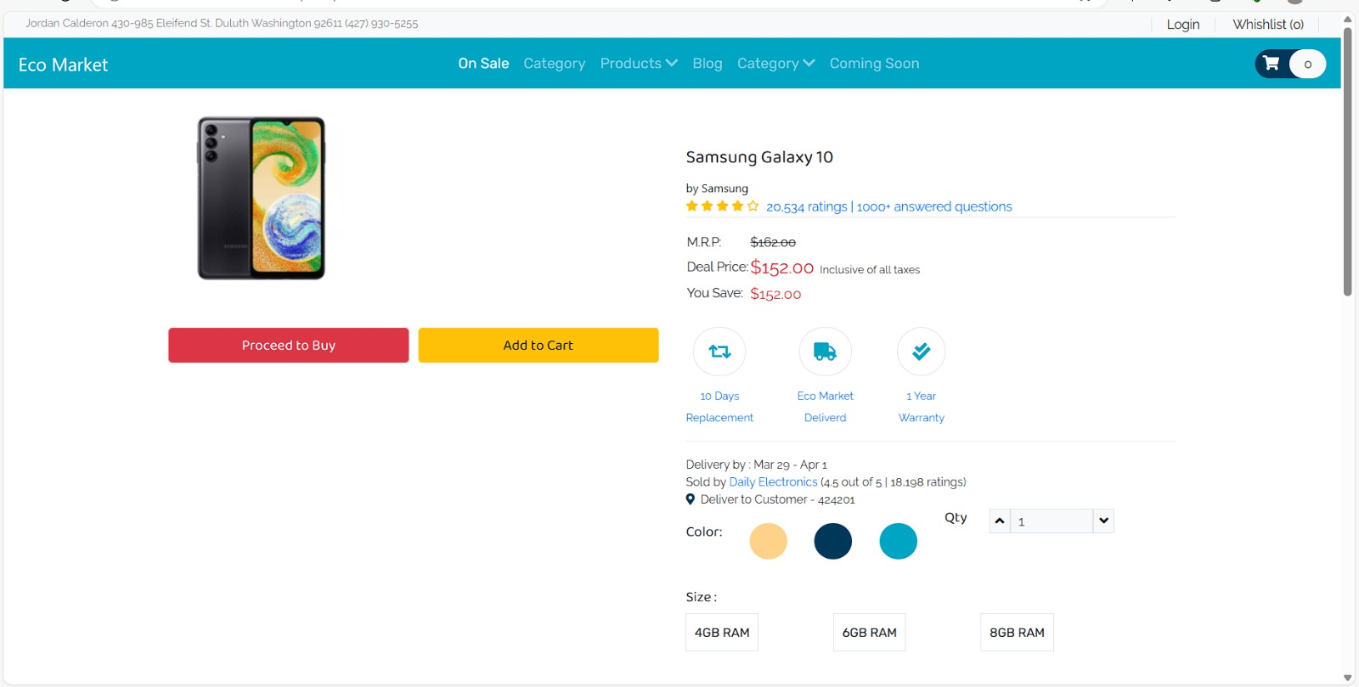

***Cart/Checkout:***

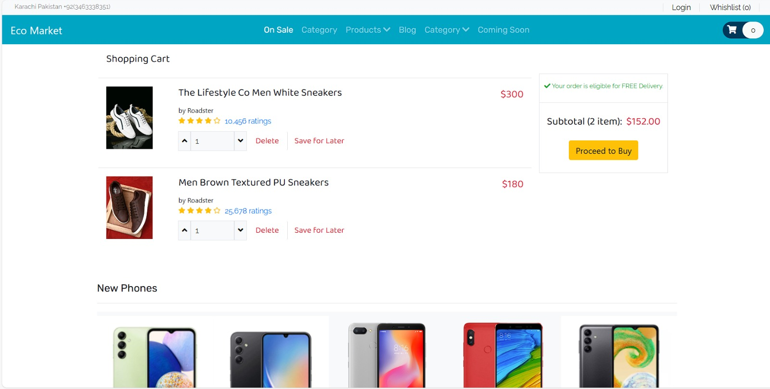

***use case diagram:***

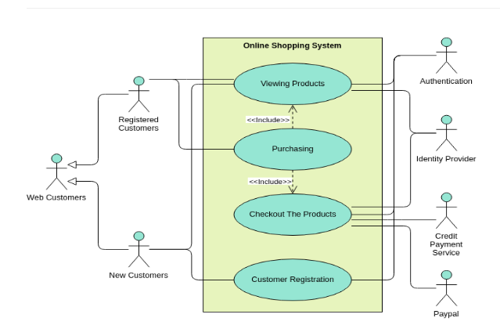

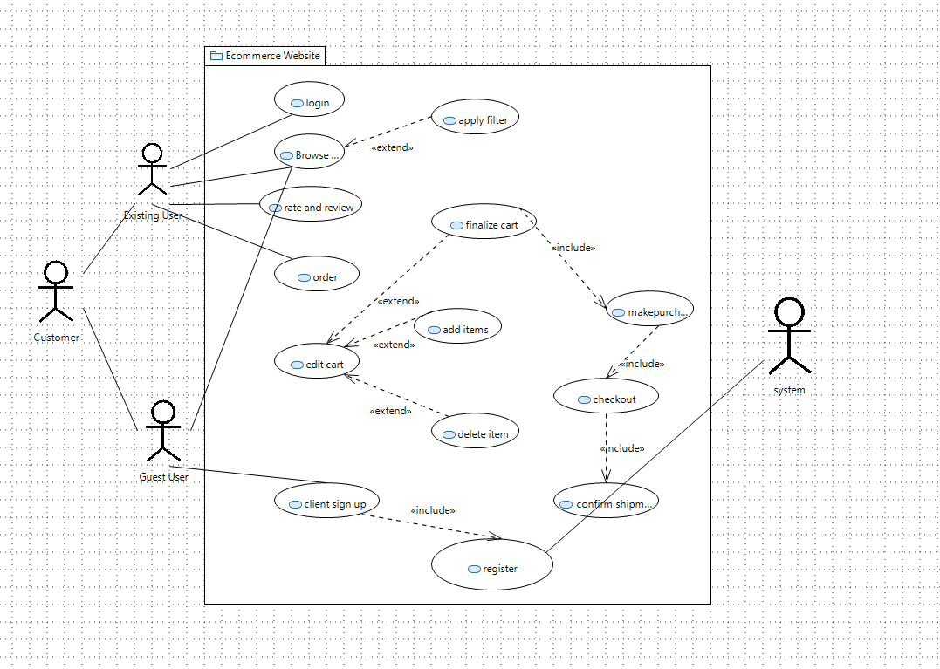

* 1. ***Product Catalog and Navigation:***

***4.1.1 Description and Priority:***

*Manage products within the e-commerce platform, including adding, updating, and removing products. Priority: High.*

***4.1.2 Stimulus/Response Sequences:***

*Stimulus: Admin adds a new product.*

*Response: System validates and adds the product to the catalog.*

*Stimulus: User updates product details.*

*Response: System updates product information in the database.*

***4.1.3 Functional Requirements:***

*REQ-1: The system shall allow administrators to add new products with details such as name, description, price, and images.*

*REQ-2: The system shall provide the capability to update product information, including price adjustments and inventory levels.*

*REQ-3: The system shall support the removal of products, ensuring data integrity and order history.*

*REQ-4: In case of duplicate product names, the system shall prompt the administrator for clarification.*

*The first system feature encompasses the creation and maintenance of an extensive product catalog. It includes functionalities for easy navigation, effective categorization, and search capabilities to enable customers to find products efficiently. This feature ensures a visually appealing and organized presentation of our product offerings.*

* 1. ***Shopping Cart and Checkout:***

*The second system feature focuses on the shopping cart and checkout process. It includes functionalities for adding products to the cart, managing the cart contents, and initiating the checkout process. This feature streamlines the purchase journey, providing a user-friendly and secure pathway for customers to complete their transactions. Additional features such as order confirmation and receipt generation contribute to a comprehensive and satisfying shopping experience.*

***4.2.1 Description and Priority:***

*Enable users to add products to their shopping cart, review the cart, and proceed through a secure checkout process. Priority: High.*

***4.2.2 Stimulus/Response Sequences:***

*Stimulus: User adds a product to the shopping cart.*

*Response: System updates the cart total and quantity.*

*Stimulus: User initiates the checkout process.*

*Response: System prompts the user for shipping and payment information.*

***4.2.3 Functional Requirements:***

*REQ-5: The system shall allow users to add products to their shopping cart.*

*REQ-6: The system shall calculate and display the total price of items in the shopping cart.*

*REQ-7: Users shall have the option to review and modify the contents of their shopping cart before proceeding to checkout.*

*REQ-8: The system shall securely handle user payment information during the checkout process.*

*REQ-9: Users shall receive an order confirmation email upon successful completion of the checkout process.*

* 1. ***User Account management:***

*The third system feature is dedicated to user account management. This includes functionalities for user registration, login, and account customization. Customers can create accounts, securely log in, and personalize their profiles. This feature enhances customer engagement by allowing users to track orders, save favorites, and manage personal information, fostering a personalized and tailored experience.*

***4.3.1 Description and Priority:***

*Allow users to create accounts, log in, and manage their personal information. Priority: Medium.*

***4.3.2 Stimulus/Response Sequences:***

*Stimulus: New user registers for an account.*

*Response: System validates the information and creates a new user account.*

*Stimulus: User logs into their account.*

*Response: System authenticates the user and grants access to account features.*

***4.3.3 Functional Requirements:***

*REQ-10: The system shall provide a user registration process with mandatory fields for email, password, and personal details.*

*REQ-11: Users shall be able to log into their accounts using valid credentials.*

*REQ-12: The system shall allow users to update their account information, including password changes and profile details.*

*REQ-13: In case of forgotten passwords, the system shall provide a secure password reset mechanism.*

* 1. ***System Feature 4: Order Processing and Fulfillment:***

*System Feature 4 addresses the critical aspect of order processing and fulfillment. This includes functionalities for processing customer orders, updating inventory levels, and coordinating shipping and delivery logistics. Efficient order management and fulfillment ensure timely and accurate delivery of products to customers, contributing to overall customer satisfaction and retention.*

***4.4.1 Description and Priority:***

*Track and manage customer orders, including order history and status updates. Priority: High.*

***4.4.2 Stimulus/Response Sequences:***

*Stimulus: User places an order.*

*Response: System confirms the order, deducts inventory, and updates order status.*

*Stimulus: User checks the order status.*

*Response: System displays the current status and tracking information.*

***4.4.3 Functional Requirements:***

*REQ-14: The system shall generate a unique order ID for each placed order.*

*REQ-15: Users shall receive an email confirmation upon order placement.*

*REQ-16: The system shall deduct product quantities from inventory upon order confirmation.*

*REQ-17: Users shall be able to view their order history, including order details and status.*

*REQ-18: Administrators shall have the ability to update order status and provide tracking information.*

1. ***Non-functional Requirements***
   1. ***Performance Requirements:***

*In the context of an e-commerce website, the imperative is to ensure optimal performance to accommodate the anticipated concurrent user load. The system must be designed to efficiently handle around 1000 users accessing the application simultaneously. Achieving this goal involves prioritizing aspects such as concurrent user handling, response time, and scalability. The system should be responsive, with an average response time ideally ranging between 1 to 3 seconds, providing users with a seamless and satisfying experience. Scalability measures, such as load balancing and optimized code, are essential to accommodate future growth without compromising performance.*

* 1. ***Safety Requirements:***

*To address safety concerns in an e-commerce setting, a robust user verification system is paramount. Only registered users should be permitted to make purchases, and implementing stringent user authentication measures, including two-factor authentication, can help prevent unauthorized access. The review and rating system should be structured to allow feedback only from users who have completed a purchase, fostering credibility and trust among the user community.*

* 1. ***Security Requirements:***

*The security requirements for an e-commerce website center around safeguarding user data, ensuring privacy, and preventing unauthorized access. Implementing data encryption protocols, such as HTTPS, is critical for securing the transmission of data between users and the server. Password security measures, including hashing with salt, protect sensitive user information. Token-based authentication, utilizing technologies like JWT, enhances the security of API endpoints, ensuring that only authorized users can access or modify data. Regular security audits, encompassing practices like penetration testing and code reviews, are essential to identify and rectify potential vulnerabilities.*

* 1. ***Software Quality Attributes:***

*In the context of our e-commerce website, the "Software Quality Attributes" section emphasizes the key characteristics that define the system's effectiveness and performance. The website prioritizes reliability, ensuring consistent and accurate functionality. Performance is optimized for quick response times and efficient handling of concurrent users. Usability is a focus, with an intuitive interface to enhance the customer experience. Stringent security measures safeguard user data and financial transactions. Scalability is inherent, accommodating potential growth seamlessly. Maintaining the system is made easy with a focus on maintainability, allowing for updates and enhancements without disruptions.*

* 1. ***Business Rules:***

*The "Business Rules" section delineates the policies governing the e-commerce website's operations. Pricing rules determine product costs, encompassing discounts, promotions, and tax considerations. Order processing rules guide procedures from confirmation to shipping and returns. User account rules dictate registration, login, and account management policies. Product listing rules govern how products are added, updated, and removed, including categorization. Payment rules specify accepted methods and transaction security measures. Shipping rules detail options, delivery times, and associated costs.*

1. ***Other Requirements***

***1.Database Requirements:***

*Specify the type of database management system (DBMS) to be used (e.g., MySQL, PostgreSQL, MongoDB).*

*Define the database schema, including tables, relationships, and constraints.*

*Detail data storage and retrieval mechanisms, especially for user profiles, product information, and order history.*

***Legal Requirements:***

*Outline compliance with data protection regulations (e.g., GDPR, CCPA).*

*Address any e-commerce-specific legal requirements or standards.*

*Clarify terms and conditions, privacy policies, and user agreements.*

***User Authentication and Authorization:***

*Specify the methods of user authentication (e.g., email/password, social media login).*

*Outline user roles and permissions, especially for administrators and customers.*

***Search and Navigation Requirements:***

*Define search functionality and filters for products.*

*Specify navigation features, such as categories, tags, and sorting options.*

***Performance Requirements:***

*Define response time expectations for different functionalities.*

*Address scalability concerns, especially during peak times.*

*Mobile Responsiveness:*

*Specify how the website should adapt to various devices (responsive design).*

*Address any mobile-specific features or considerations.*

1. ***Appendix:A Glossary***

*Cart: A virtual space where users can add and manage selected items before proceeding to checkout.*

*CMS: Content Management System. A tool for managing website content, including product descriptions and images.*

*CSS: Cascading Style Sheets. Code used to style the visual presentation of the website.*

*E-commerce: Electronic Commerce. Online buying and selling of products and services.*

*HTML: Hypertext Markup Language. The standard language for creating and structuring web pages.*

*HTTPS: Hypertext Transfer Protocol Secure. The secure version of HTTP, ensuring encrypted data transfer.*

*SSL/TLS: Secure Sockets Layer/Transport Layer Security. Protocols for securing online communication.*

*UI: User Interface. The visual elements and layout of the website that users interact with.*

*UX: User Experience. The overall experience users have while navigating and interacting with the website.*

*XML: Extensible Markup Language. A format for encoding documents that is both human-readable and machine-readable.*

1. ***Appendix :B Analysis Models***
   1. ***Class Diagram:***

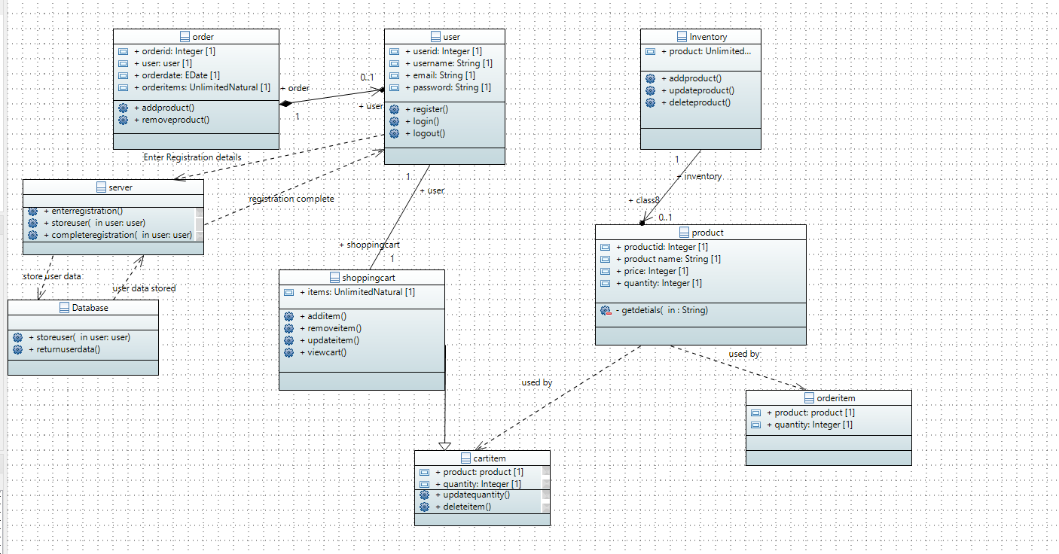

* 1. ***Sequence Diagram:***

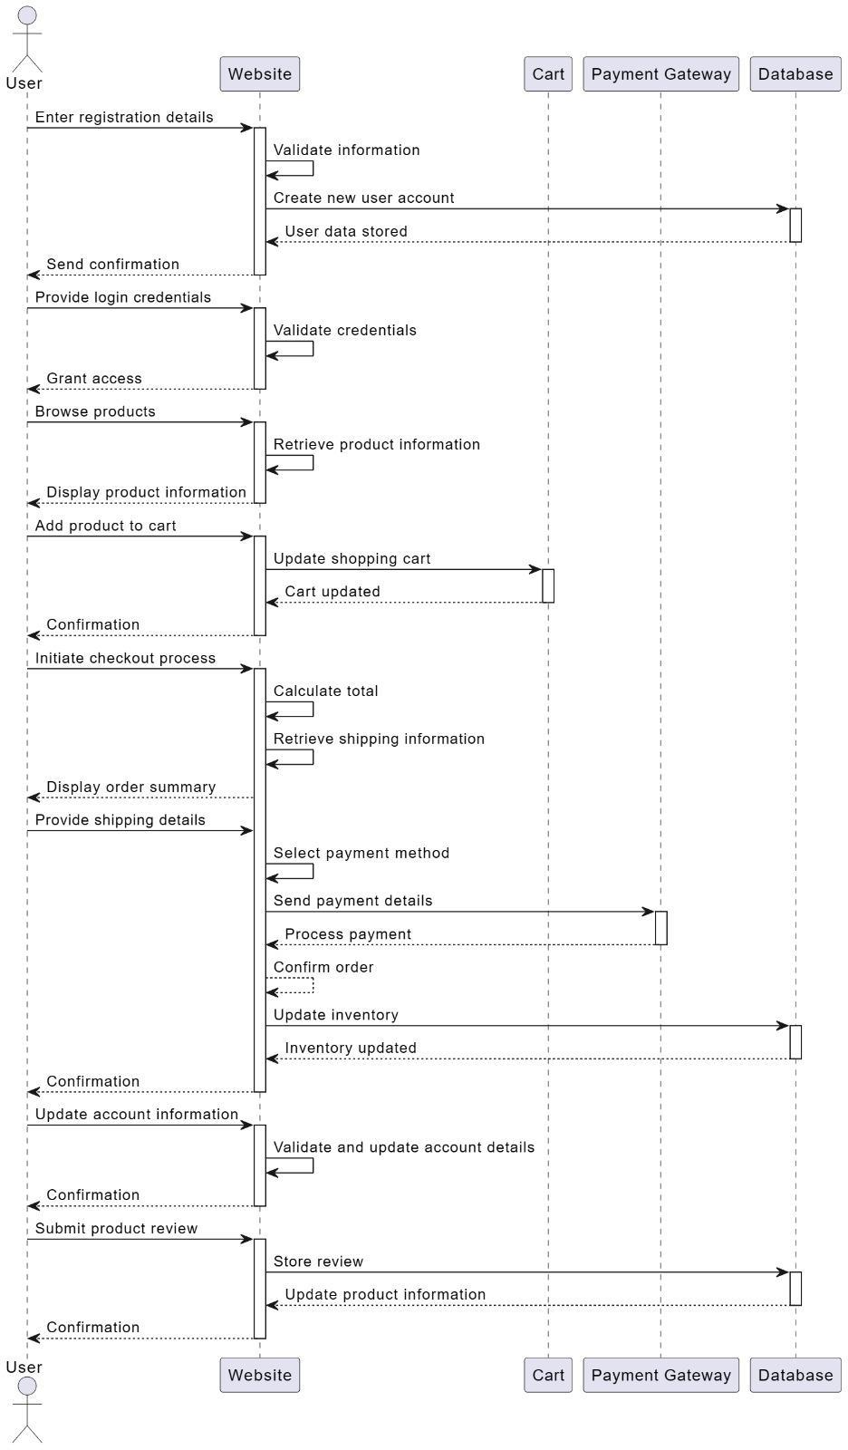

* 1. ***Activity Diagram:***

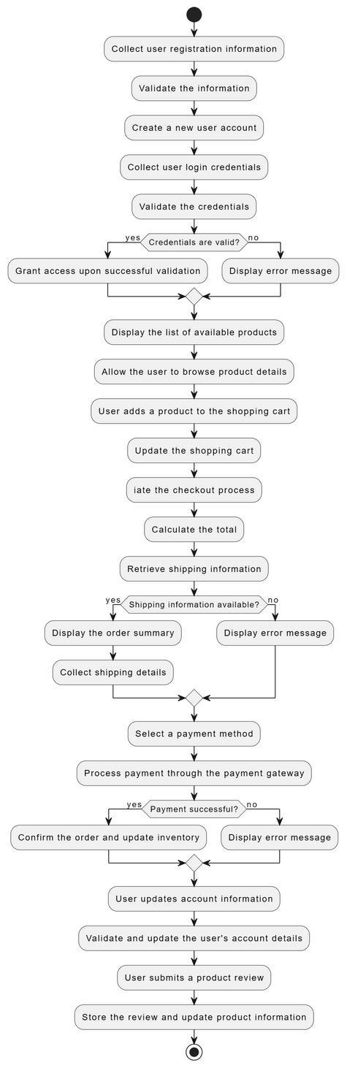

* 1. ***Component Diagram:***

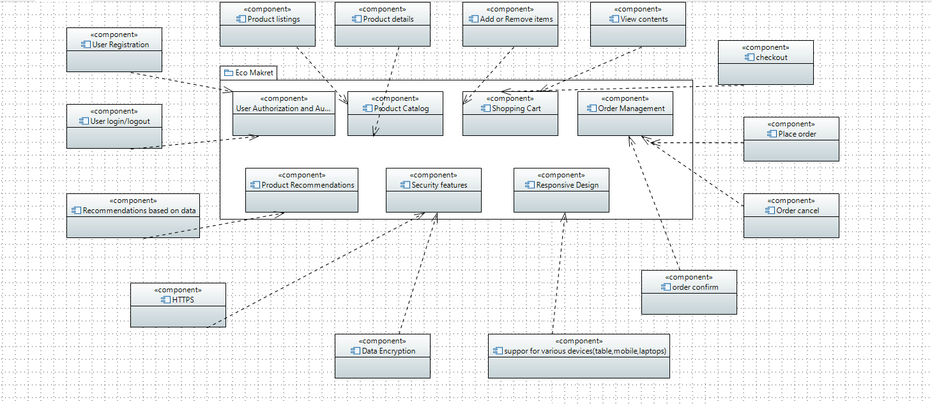

* 1. ***Collaboration Diagram:***

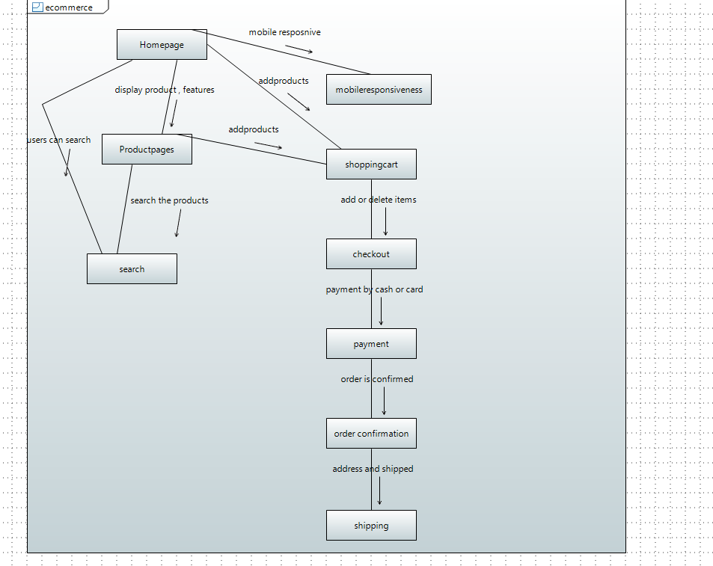

* 1. ***State Diagram:***

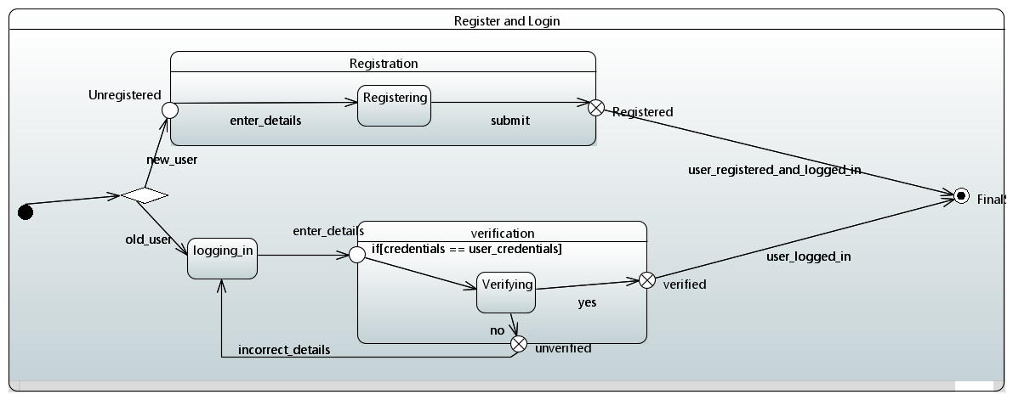

*Registration here is composite state because it consist of verifying state which itself is a state which much happening in it like entering details and submission. The user being registered from unregistered. Together with this Verification is a composite state as in it verifying of credentials is done with conditions that is the verification of user credentials is done or not so there is much happening in it. There is very much happening in these states that’s why they are kept composite as composite state can have one or more states in it.*

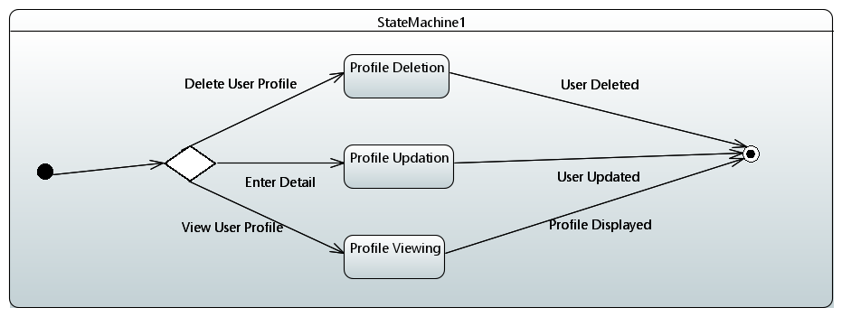

* 1. ***Deployment Diagram:***

